PROJECT EXPO-26
PHASE 3: System Design Review, Deliverables

SECURE MOBILE WEB-BASED REMOTE VOTING SYSTEM

Team Members: Vaishika T.A, Ezhilvizhi R,
Babykarthika S

Overall System Flowchart:

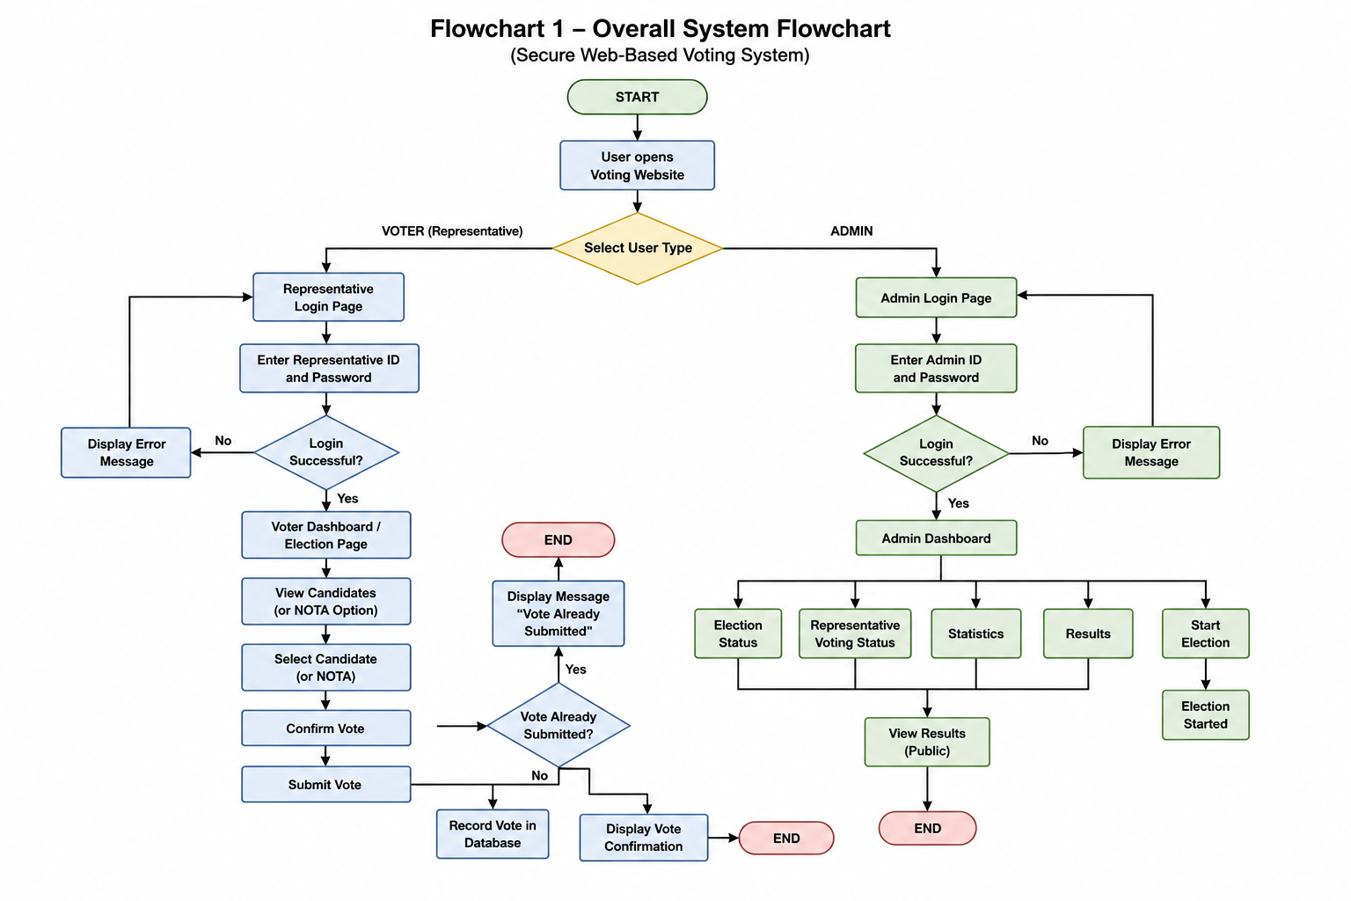

Voting Website Process Flowchart:
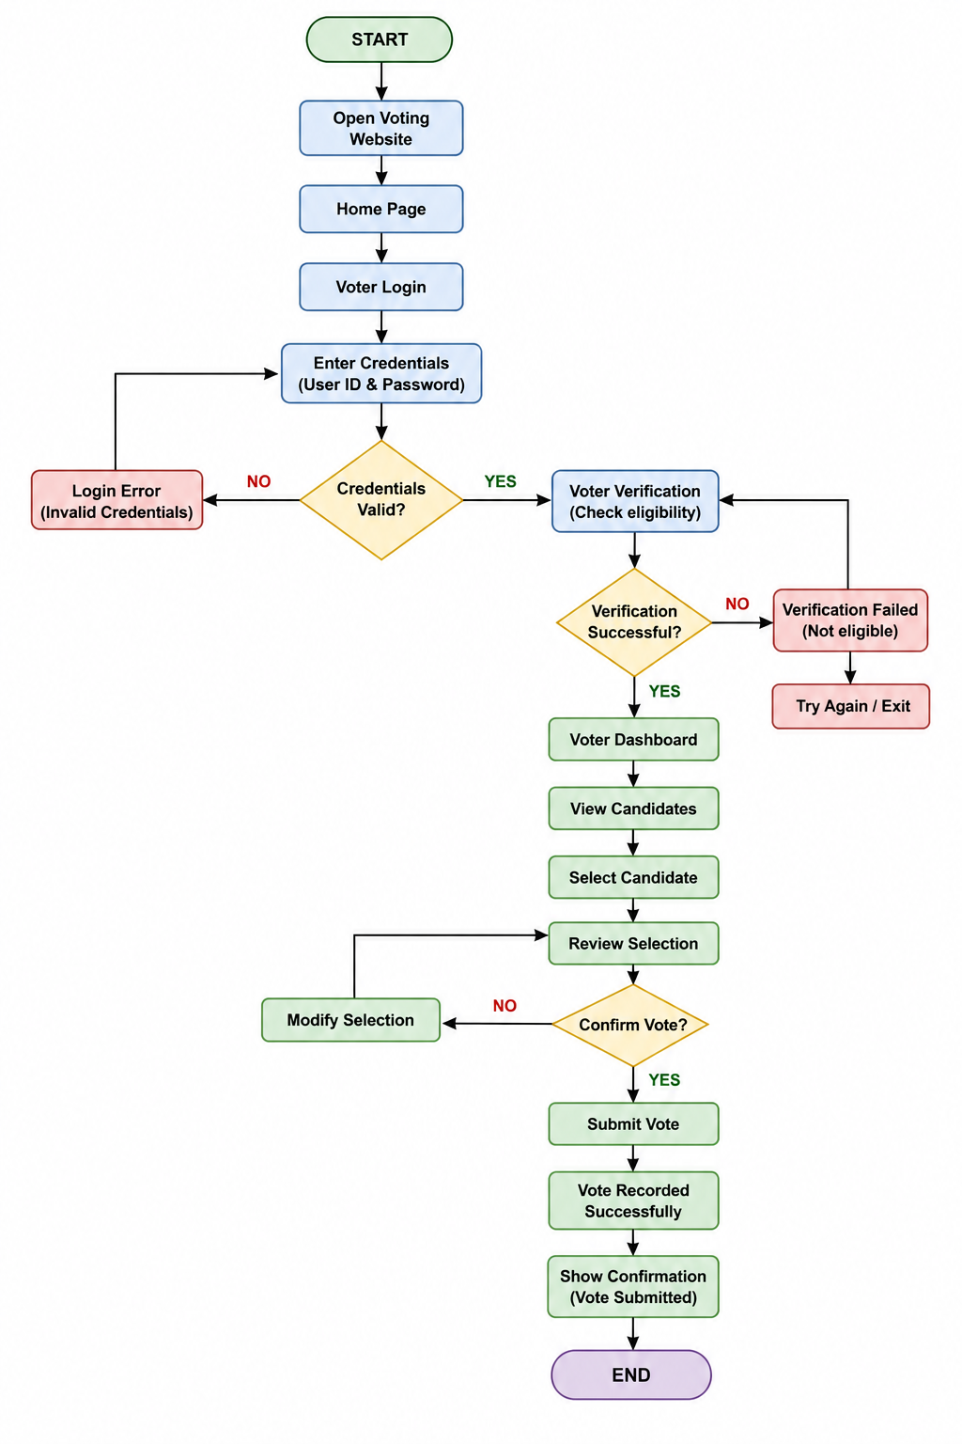

Voting System Flowchart:

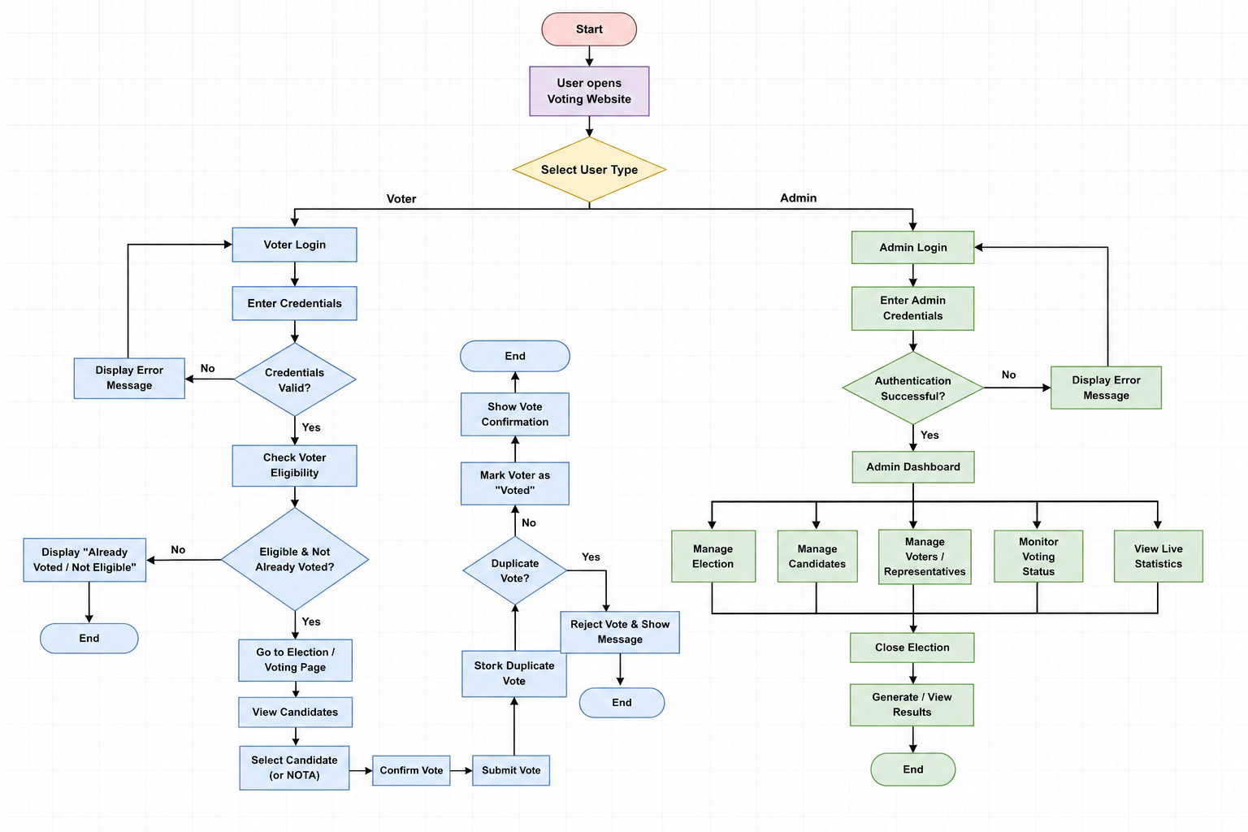

Voter/User Flowchart
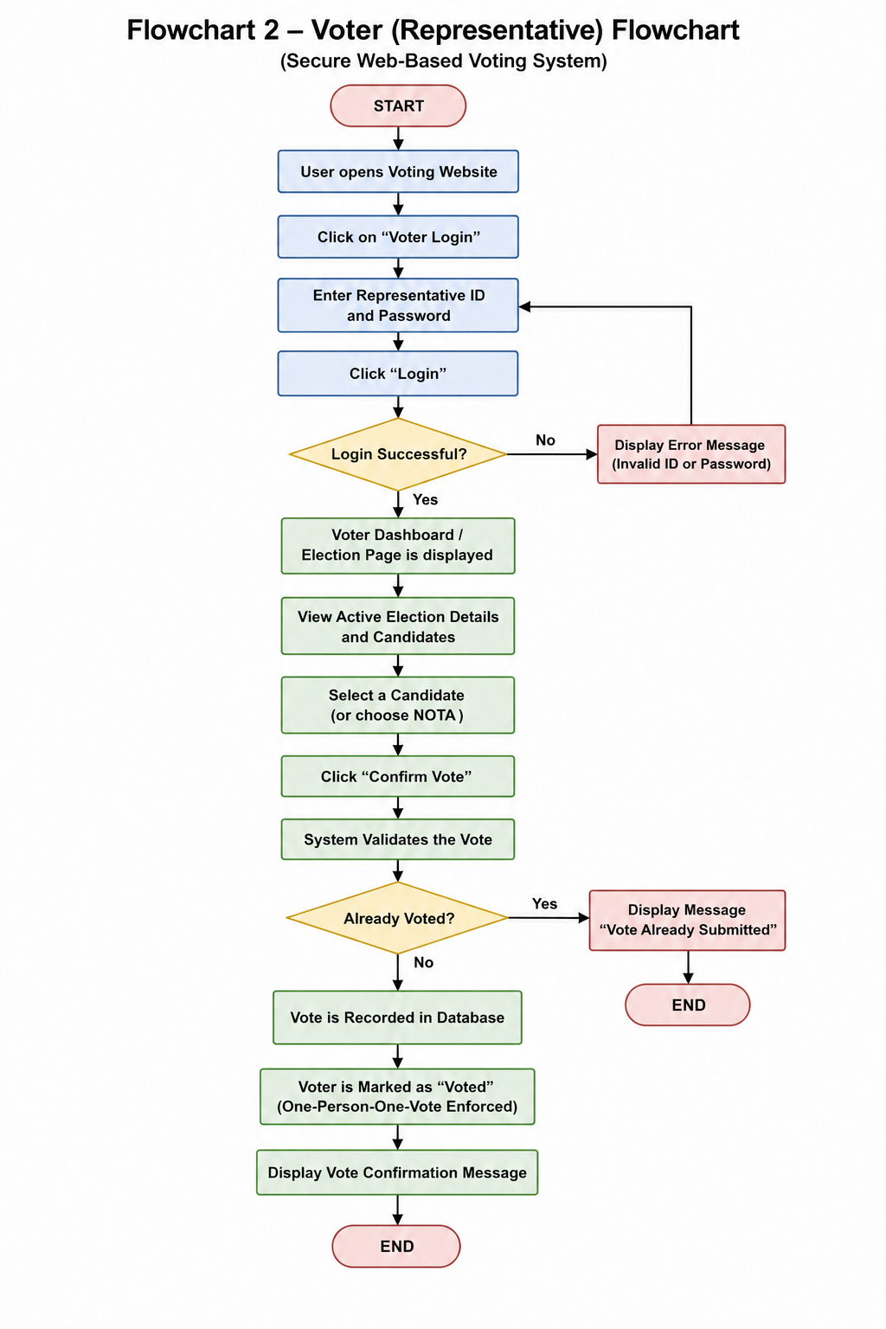
Admin Flowchart:
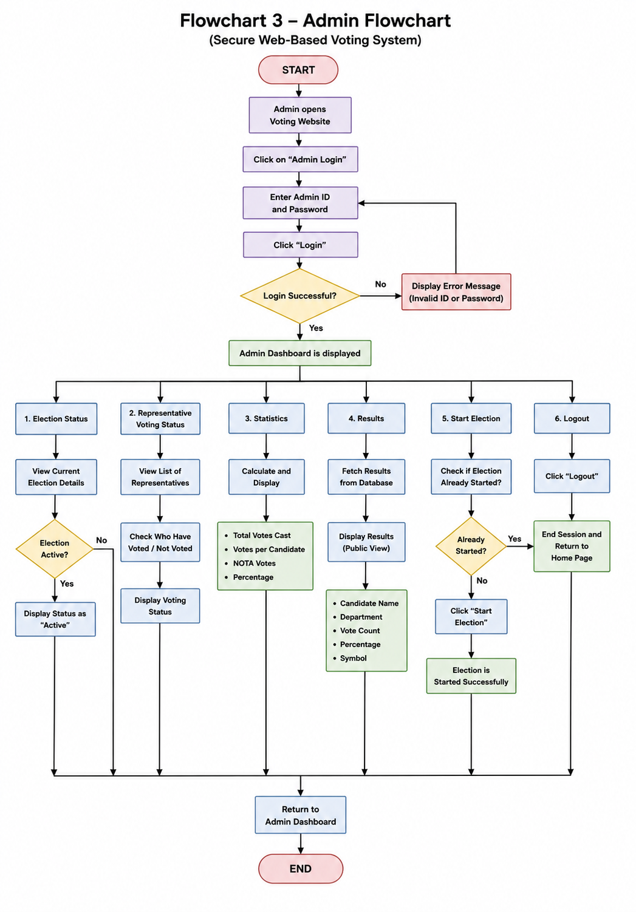
Vote Validation / Duplicate Vote Prevention Flowchart:
